BLOCK DIAGRAM:
Analyzer
RS485 COMMUNICATION
Aster brand flow meter
INLET
Aster brand flow meter
OUTLET

Arduino UNO
TFT display for Flow meter Data displaying
RS485 converter
Module
RS485 communication
From analyzer
Raspberry pi
(Server)
SQL
Data logger
COD BOD TSS
Water quality
Level Sensor
(RS485 communication)
PH Water quality Level Sensor
LCD
Main display
Data push to
ADHAV TECH
ESP32
Sensor Station

Figure 1: General Block diagram of Analyser

NOTES:
Scope of the projects

QUICK ENGINEERING GOWATER PVT LTD ADHAV TECH

Hardware images:
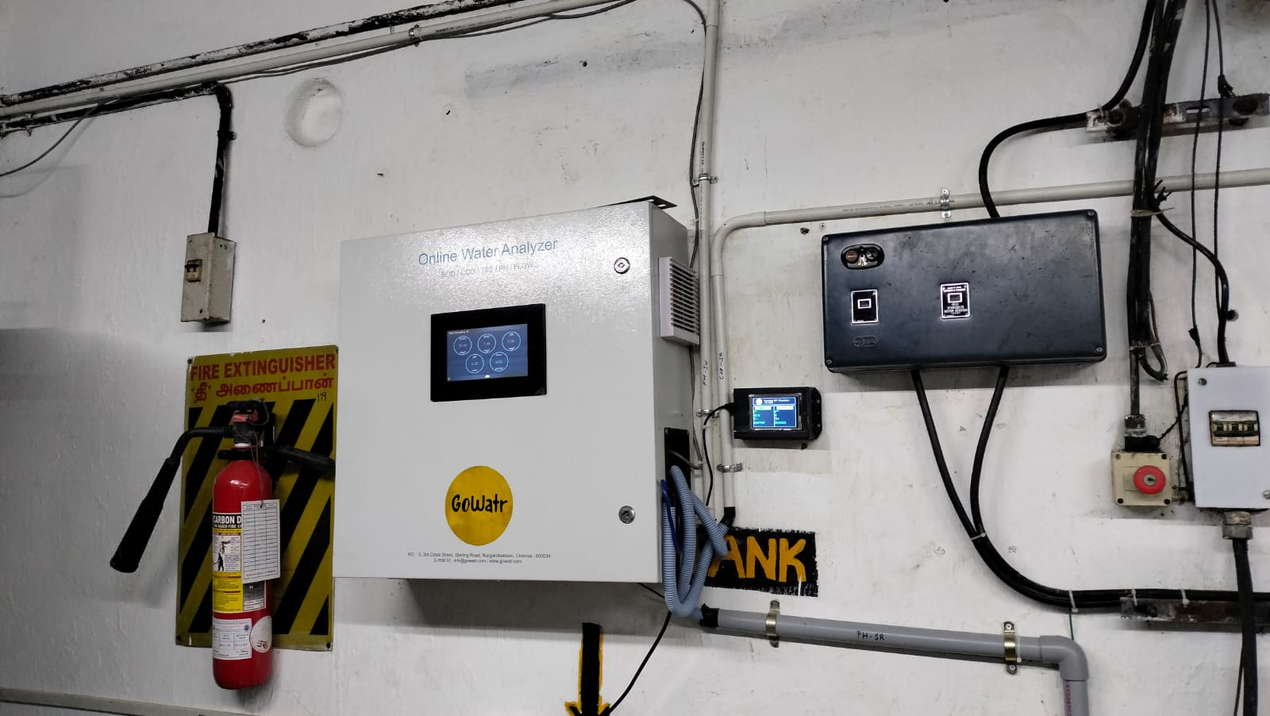
Figure 2: Front view of installed analyser image (original)

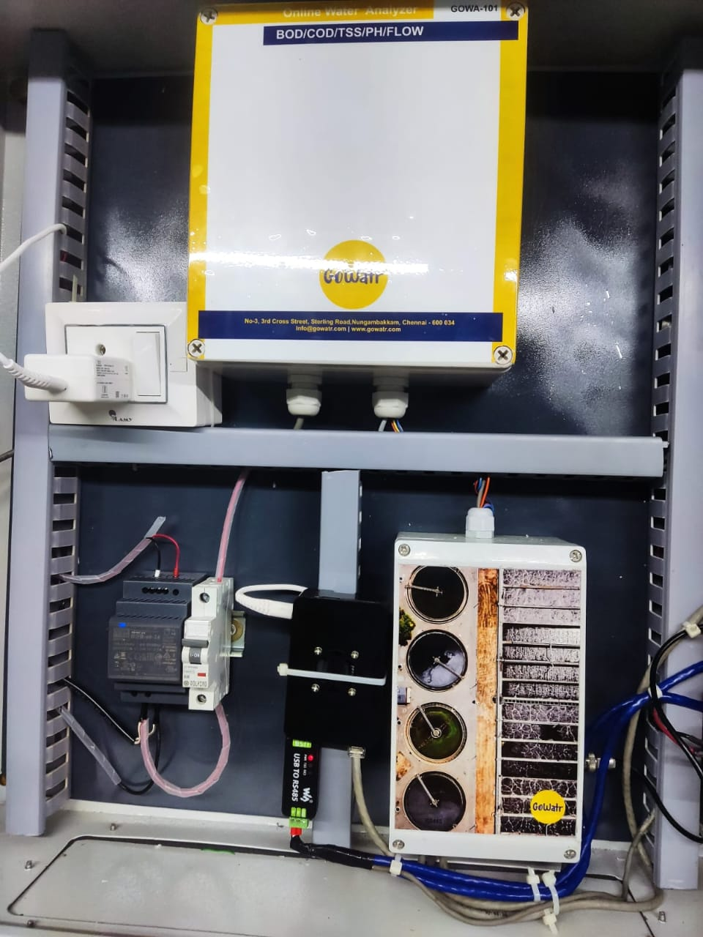
Figure 3: inner circuit images

Software Implementation
1.1 Raspberry Pi program
#updated on 28.09.2023
import minimalmodbus
import serial
import time
import struct
import json
import requests
from serial.tools import list_ports

cod = 0.0
bod = 0.0
tss = 0.0
ph = 0.0
tot1 = 0.0
flow1 = 0.0
tot2 = 0.0
flow2 = 0.0

flow11 = 0
tot11 = 0

# Function to automatically find the Arduino port on both Windows and Linux
def find_arduino_port():
arduino_ports = [p.device for p in list_ports.comports() if 'Arduino' in p.description]
if not arduino_ports:
arduino_ports = [p.device for p in list_ports.comports() if 'ttyACM' in p.device]
if not arduino_ports:
raise IOError("No Arduino found. Check if it's connected.")
return arduino_ports[0]
try:
# Automatically find the Arduino port
arduino_port = find_arduino_port()

# port name, slave address (in decimal)
ser = serial.Serial(arduino_port, 9600, timeout=1)
except IOError as e:
print(e)
ser = None

an_instrument = minimalmodbus.Instrument('/dev/ttyUSB0', 1)
fm1_instrument = minimalmodbus.Instrument('/dev/ttyUSB0', 2)
fm2_instrument = minimalmodbus.Instrument('/dev/ttyUSB0', 3)
an_instrument.serial.baudrate = fm1_instrument.serial.baudrate = fm2_instrument.serial.baudrate = 9600
an_instrument.serial.bytesize = fm1_instrument.serial.bytesize = fm2_instrument.serial.bytesize = 8
an_instrument.serial.stopbits = fm1_instrument.serial.stopbits = fm2_instrument.serial.stopbits = 1
an_instrument.serial.timeout = fm1_instrument.serial.timeout = fm2_instrument.serial.timeout = 1
an_instrument.mode = fm1_instrument.mode = fm2_instrument.mode = minimalmodbus.MODE_RTU
an_instrument.clear_buffers_before_each_transaction = fm1_instrument.clear_buffers_before_each_transaction = fm2_instrument.clear_buffers_before_each_transaction = True
an_instrument.debug = fm1_instrument.debug = fm2_instrument.debug = True

def analyzer_cod():
try:
reg0 = an_instrument.read_register(0, 0, 3)
reg1 = an_instrument.read_register(1, 0, 3)
regset1 = hex((reg1<<16) | reg0)[2:]
regset1_str = str(regset1)
f_cod = struct.unpack('>f', bytes.fromhex(regset1_str))[0]
cod = round(f_cod, 2)
print("The COD HEX is : ", regset1_str)
print("The COD Value is : ", cod)
cod_data = "http://localhost/push/push.php?id=cod&cod={}".format(cod)
update_cod_api = requests.get(cod_data)
print(cod_data)
print(update_cod_api.status_code)
an_instrument.serial.close()

except (minimalmodbus.NoResponseError, minimalmodbus.InvalidResponseError, ValueError, UnboundLocalError) as error:
print("Error in response of cod")
############################################
def analyzer_bod():
try:
reg2 = an_instrument.read_register(2, 0, 3)
reg3 = an_instrument.read_register(3, 0, 3)
regset2 = hex((reg3<<16) | reg2)[2:]
regset2_str = str(regset2)
f_bod = struct.unpack('>f', bytes.fromhex(regset2_str))[0]
bod = round(f_bod, 2)
print("The BOD HEX is : ", regset2_str)
print("The BOD Value is : ", bod)
bod_data = "http://localhost/push/push.php?id=bod&bod={}".format(bod)
update_bod_api = requests.get(bod_data)
print(bod_data)
print(update_bod_api.status_code)
an_instrument.serial.close()

except (minimalmodbus.NoResponseError, minimalmodbus.InvalidResponseError, ValueError) as error:
print("Error in response of bod")
############################################
def analyzer_tss():
global tss # Use global variable
try:
reg4 = an_instrument.read_register(4, 0, 3)
reg5 = an_instrument.read_register(5, 0, 3)
regset3 = hex((reg5<<16) | reg4)[2:]
regset3_str = str(regset3)
try:
f_tss = struct.unpack('>f', bytes.fromhex(regset3_str))[0]
except (struct.error, ValueError):
f_tss = 0.0

tss = round(f_tss, 2)
print("The TSS HEX is : ", regset3_str)
print("The TSS Value is : ", tss)
tss_data = "http://localhost/push/push.php?id=tss&tss={}".format(tss)
update_tss_api = requests.get(tss_data)
print(tss_data)
print(update_tss_api.status_code)
an_instrument.serial.close()

except (minimalmodbus.NoResponseError, minimalmodbus.InvalidResponseError) as error:
print("Error in response of tss")
############################################
def analyzer_ph():
try:
reg6 = an_instrument.read_register(6, 0, 3)
reg7 = an_instrument.read_register(7, 0, 3)
regset4 = hex((reg7<<16) | reg6)[2:]
regset4_str = str(regset4)
f_ph = struct.unpack('>f', bytes.fromhex(regset4_str))[0]
ph = round(f_ph, 2)
print("The PH HEX is : ", regset4_str)
print("The PH Value is : ", ph)
ph_data = "http://localhost/push/push.php?id=ph&ph={}".format(ph)
update_ph_api = requests.get(ph_data)
print(ph_data)
print(update_ph_api.status_code)

an_instrument.serial.close()

except (minimalmodbus.NoResponseError, minimalmodbus.InvalidResponseError, ValueError) as error:
print("Error in response of ph")

def flowmeter1():
try:
response = fm1_instrument.read_registers(0, 10, 3)
tot1 = ((response[3] << 16) | response[2])
#tot1 = tot1
#tot1 = "{:.1f}".format(tot1)
flow1 = response[1]
flow11 = flow1
tot11 = tot1
print("The inlet fm totalizer is : ", tot1, "LPH")
print("The inlet fm flowrate is : ", flow1, "LPH")

fm1_data = "http://localhost/push/push.php?id=fm1&fmid1=001&tot1={}&flow1={}".format(tot1,flow1)
update_fm1_api = requests.get(fm1_data)
print(fm1_data)
print(update_fm1_api.status_code)
#time.sleep(2)
sensor_name = "Flow"
sensor_value = flow1
send_sensor_data(sensor_name , sensor_value)
#time.sleep(2)
sensor_name = "Tot"
sensor_value = tot1
send_sensor_data(sensor_name , sensor_value)
#time.sleep(2)
fm1_instrument.serial.close()

except (minimalmodbus.NoResponseError, minimalmodbus.InvalidResponseError) as error:
print("Error in response of FM1")

def flowmeter2():
try:
response2 = fm2_instrument.read_registers(0, 8, 3)
tot2 = ((response2[3] << 16) | response2[2])
#tot2 = tot2
#tot2 = "{:.1f}".format(tot2)
flow2 = response2[1]
print("The outlet fm totalizer is : ", tot2, "LPH")
print("The outlet fm flowrate is : ", flow2, "LPH")

fm2_data = "http://localhost/push/push.php?id=fm2&fmid2=002&tot2={}&flow2={}".format(tot2,flow2)
update_fm2_api = requests.get(fm2_data)
print(fm2_data)
print(update_fm2_api.status_code)
#time.sleep(2)
sensor_name = "Flow2"
sensor_value = flow2
send_sensor_data(sensor_name , sensor_value)
#time.sleep(2)
sensor_name = "Tot2"
sensor_value = tot2
send_sensor_data(sensor_name , sensor_value)
#time.sleep(2)
fm2_instrument.serial.close()

except (minimalmodbus.NoResponseError, minimalmodbus.InvalidResponseError) as error:
print("Error in response of FM2")

def send_sensor_data(sensor_name, sensor_value):
data = f"{sensor_name}:{sensor_value}\n"
ser.write(data.encode())

while True:
analyzer_cod()
analyzer_bod()
analyzer_tss()
analyzer_ph()
time.sleep(5)
flowmeter1()
time.sleep(5)
flowmeter2()

#send_sensor_data(sensor_name, sensor_value)

time.sleep(1)
time.sleep(20)

2.1 Arduino UNO program:
#include <Adafruit_GFX.h>
#include <MCUFRIEND_kbv.h>
#include <stdio.h> //input output library
#include <stdint.h> //integer type library
#include <string.h> //string library
#include <Wire.h>
MCUFRIEND_kbv tft;

#define LOWFLASH (defined(__AVR_ATmega328P__) && defined(MCUFRIEND_KBV_H_))
#include "bitmap_RGB.h"
//#include "image.h"
#define BLACK 0x0000
#define BLUE 0x001F
#define RED 0xF800
#define GREEN 0x07E0
#define CYAN 0x07FF
#define MAGENTA 0xF81F
#define YELLOW 0xFFE0
#define WHITE 0xFFFF
#define GREY 0x8410
#define ORANGE 0xE880
float InletFlow;
float InletTot;
float OutletFlow;
float OutletTot;
float i=0;
float j=0;
int width = 320;
int height = 480;

void logo(int x, int y, int w, int h) {
tft.drawRGBBitmap(x, y, gowatr_64x64, w, h);
//tft.drawRGBBitmap(x+200, y, somerset_64x64, w, h);
}

void setup() {
Serial.begin(9600); // Set the baud rate to match the Raspberry Pi
uint16_t ID = tft.readID();
Serial.print("TFT ID = 0x");
Serial.println(ID, HEX);
if (ID == 0xD3D3) ID = 0x9486; // write-only shield
tft.begin(ID);
tft.setRotation(1); //PORTRAIT
tft.fillScreen(BLACK);
tft.setTextColor(YELLOW, BLACK);
tft.setTextSize(2);
// testing();
tft.setTextSize(2);
tft.setCursor(135, 25);
tft.setTextColor(WHITE,BLACK);
tft.print("Somerset STP Flowmeters");
tft.setTextSize(2);
tft.setCursor(135, 47);
tft.print("(in LPH)");
printUI();
}

void loop() {
if (Serial.available() > 0) {
String sensorData = Serial.readStringUntil('\n');
// Parse received data
int separatorIndex = sensorData.indexOf(':');
if (separatorIndex != -1) {
String sensorName = sensorData.substring(0, separatorIndex);
if(sensorName.equals("Flow"))
{
float InletFlow = sensorData.substring(separatorIndex + 1).toFloat();
Serial.print("Received Sensor: ");
Serial.print(sensorName);
Serial.print(", Value: ");
Serial.println(InletFlow);
tft.fillRect(8,179,220,27,BLACK);
tft.setCursor(10, 180);
tft.setTextSize(3);
tft.print(InletFlow);
}
if(sensorName.equals("Tot"))
{
float InletTot = sensorData.substring(separatorIndex + 1).toFloat();
Serial.print("Received Sensor: ");
Serial.print(sensorName);
Serial.print(", Value: ");
Serial.println(InletTot);
tft.fillRect(8,258,220,27,BLACK);
tft.setCursor(10, 260);
tft.setTextSize(3);
tft.print(InletTot);
}
//////////////////////////////////////////////////////////////////
if(sensorName.equals("Flow2"))
{
float OutletFlow = sensorData.substring(separatorIndex + 1).toFloat();
Serial.print("Received Sensor: ");
Serial.print(sensorName);
Serial.print(", Value: ");
Serial.println(OutletFlow);
tft.fillRect(248,179,220,27,BLACK);
tft.setCursor(249, 180);
tft.setTextSize(3);
tft.print(OutletFlow);
}
if(sensorName.equals("Tot2"))
{
float OutletTot = sensorData.substring(separatorIndex + 1).toFloat();
Serial.print("Received Sensor: ");
Serial.print(sensorName);
Serial.print(", Value: ");
Serial.println(OutletTot);
tft.fillRect(248,258,220,27,BLACK);
tft.setCursor(249, 260);
tft.setTextSize(3);
tft.print(OutletTot);
delay(1000);
}
}
}
}

void printUI()
{
tft.drawRoundRect(5,5,470,71,5,TFT_WHITE);
tft.drawRoundRect(6,6,470,71,5,TFT_WHITE);

tft.drawRoundRect(5,90,235,225,5,TFT_WHITE);
tft.drawRoundRect(6,91,235,225,5,TFT_WHITE);

tft.drawRoundRect(240,90,235,225,5,TFT_WHITE);
tft.drawRoundRect(241,91,235,225,5,TFT_WHITE);

logo(40, 10, 64, 64);

tft.fillRect(26,90,180,40,TFT_GREEN);
tft.fillRect(270,90,180,40,TFT_CYAN);

tft.setCursor(62,100);
tft.setTextColor(TFT_BLACK);
tft.setTextSize(3);
tft.print("INLET");

tft.setCursor(10,140);
tft.setTextColor(TFT_GREEN);
tft.setTextSize(4);
tft.print("F~");

tft.setCursor(10,215);
tft.setTextColor(TFT_GREEN);
tft.setTextSize(4);
tft.print("T+");
//////////////////////////////////////////////////////////////////////

tft.setCursor(312,100);
tft.setTextColor(TFT_BLACK);
tft.setTextSize(3);
tft.print("OUTLET");

tft.setCursor(250,140);
tft.setTextColor(TFT_CYAN);
tft.setTextSize(4);
tft.print("F~");

tft.setCursor(250,215);
tft.setTextColor(TFT_CYAN);
tft.setTextSize(4);
tft.print("T+");

/*tft.setCursor(210,245);
tft.setTextColor(TFT_GREEN);
tft.setTextSize(2);
tft.print("+");*/

/*tft.setCursor(455,245);
tft.setTextColor(TFT_CYAN);
tft.setTextSize(2);
tft.print("+");*/
}

Embedded Program Files:
- Python Script:

- Arduino code:

